Dear Community Member,
The Town of Jean Lafitte’s Seafood Festival is back for the second year in a row despite the devastation caused by Hurricane Ida. In these past years, our seafood industry, as well as our entire community, has taken a huge hit and the time is now to support our local fishermen.
The Jean Lafitte Seafood Festival is actively seeking members and/or businesses in our community willing to help support the events and activities for the Jean Lafitte Seafood Festival. This year’s fair will be held June 10th and June 11th. We are excited to add some new events, along with welcoming back old traditions.
The Town of Jean Lafitte has been working to improve the event to better serve its residents and visitors. All donations are put toward fair grounds improvements or entertainment during the fair. We are happy to speak with you about Event and Custom Sponsorship availability.
In keeping with the traditions of the past fairs and looking to the exciting opportunities for future fairs, we are asking for your support to continue to this tradition along with fun, family events supporting the Jean Lafitte Seafood Festival.

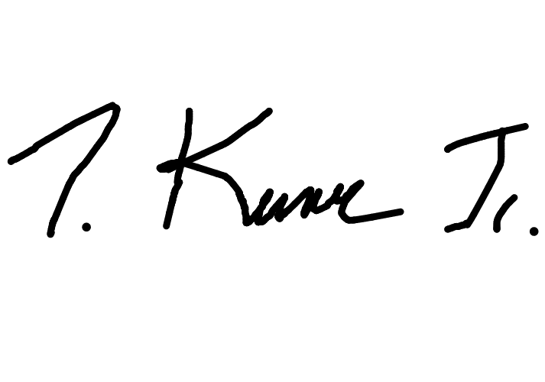
Thank You,

Timothy P. Kerner, Jr. Mayor, Town of Jean Lafitte

SPONSORSHIP OPPORTUNITIES

CYPRESS SPONSOR ‐ $500
- YOUR 2’x4’ Banner displayed at fair*
- Listed on website as sponsor

OYSTER SPONSOR ‐ $1000
- YOUR 2’x4’ Banner displayed at fair*
- Listed on website as sponsor
- Your name displayed on electric sign in front of the fair

ALLIGATOR SPONSOR ‐ $1500
- YOUR 2’x4’ Banner displayed at fair*
- Listed on website as sponsor
- Your company sponsorship mentioned in announcements during the fair
- Your name displayed on electric sign in front of the fair

CRAB SPONSOR ‐ $2000
- YOUR 4’X8’ Banner displayed at fair*
- Listed on website as sponsor
- Your company sponsorship mentioned in announcements during the fair
- Your name displayed on electric sign in front of the fair

SHRIMP SPONSOR ‐ $2500
- YOUR 4’X8’ Banner displayed at fair*
- Listed on website as sponsor
- Your company sponsorship mentioned in announcements during the fair
- Your name displayed on electric sign in front of the fair
- Your logo on admissions gate

FISHERMEN SPONSOR ‐ $5000
- YOUR 4’X8’ Banner displayed at fair*
- Listed on website as sponsor
- Your company sponsorship mentioned in announcements during the fair
- Your name displayed on electric sign in front of the fair
- Your logo on fair stage

COASTAL SPONSOR ‐ $10,000
- YOUR 4’X8’ Banner displayed at fair*
- Listed on website as sponsor
- Your company sponsorship mentioned in announcements during the fair
- Your name displayed on electric sign in front of the fair
- Your logo on fair stage
- Your logo on all fair maps and flyers
*Sponsor provides banner. Town will provide banner at an additional cost of $45 for 2’x4’ or $99 for 4’x8’.

SPONSORSHIP FORM

Company Name:
Contact Name/Title:
Address:
Phone Number:
Email Address:

PLEASE CHECK OFF CORRECT BOX FOR DESIRED SPONSOR PARTNERSHIP LEVEL

Sponsorship Level | Donation Amount | Check
Cypress Sponsor | $500.00
Oyster Sponsor | $1,000.00
Alligator Sponsor | $1,500.00
Crab Sponsor | $2,000.00
Shrimp Sponsor | $2,500.00
Fisherman Sponsor | $5,000.00
Coastal Sponsor | $10,000.00

Will provide own sign.
Will purchase sign through town: $45 for 2’x4’ or $99 for 4’x8’.
Please make checks payable to: Town of Jean Lafitte, 2654 Jean Lafitte Blvd, Lafitte, LA, 70067.

Authorized Signature Title Date

TO RECEIVE MAXIMUM BENEFIT FROM YOUR SPONSORSHIP PLEASE RESPOND BY MAY 10, 2022

Custom event and sponsorships available. Please call us at (504) 689‐2208.

