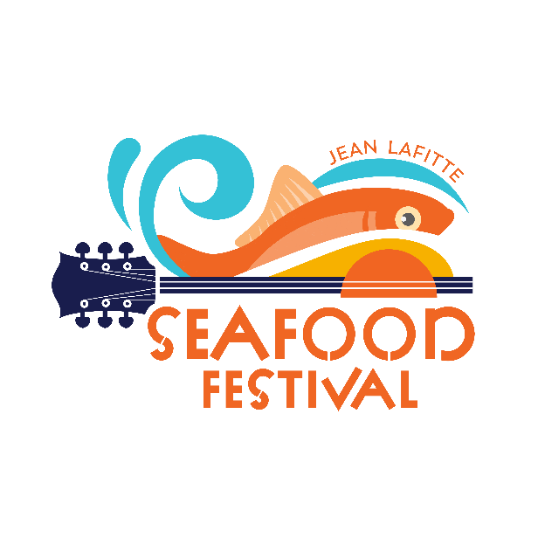

Town of Jean Lafitte Seafood Festival Craft/Art Vendor Application Application Deadline: May 10, 2022
Payment Deadline: May 10, 2022

Name:

Company/Business Name:

Phone: Cell:

Email:

Address: City: State: Zip:

Describe the sales or activity you propose in detail. ALL items sold or promoted MUST be listed. Attach a separate sheet of paper if needed. You will be contacted and advised if your booth is approved.

BOOTH FEES ARE: $50.00

Event Hours:
Friday, June 10th: 5:00 pm - 11:00 pm Saturday, June 11th: 11:00 am - 11:00 pm

I am applying for a space in the JEAN LAFITTE SEAFOOD FESTIVAL. I agree to follow all of the rules put forth by the Festival.
There are NO refunds for no shows. The Festival goes on rain or shine. Please take note of and initial the special rules below. ALL VENDORS:
- Vendors must be in assigned 10' x 10' space and set up for business one hour prior to festival opening. All vehicles must be off festival grounds one hour prior to festival opening.

- ______ Vendors are responsible for transportation of their own goods.

- ______ Vendors are responsible for securing their goods and/or space at night and in the event of rain.

- Vendors are responsible for cleaning up their booth area. This includes removing all trash (to be placed in the dumpster) and hosing down any spills that may occur. If booth is not cleaned, a $50 cleaning fee will be charged.

- Vendors must keep their booth open for the duration of the event, for both days.

- Vendors are responsible for filing and paying any appropriate sales tax to Jefferson Parish and the State of Louisiana.

- The Town will be selling beverages: soft drinks, water, beer, alcoholic beverages, etc.; vendors may not sell beverages of any kind.

- No silly string, confetti eggs or gum can be sold at the market at any time.

- Beyond the placement fee, the vendor retains all profits from their sales.

- Vendors must be prepared to make change for purchases.

The regulations printed herein may be changed, modified and/or updated at any time and without prior notice.

SIGNED: DATE:
- All sections of the application must be completed. Be sure to initial at all indicated places.
- Please return this application to: Jean Lafitte Seafood Festival, Attn: Jeff Adam, 2654 Jean Lafitte Blvd., Lafitte, LA
- IF paying by check, make checks payable to Town of Jean Lafitte
- For questions regarding application, please contact Jeff Adam or Yvette Crain at (504)689-2208, or email
jadam@townofjeanlafitte.com

